**blocking vs. non-blocking**

Blocking and non-blocking are terms used to describe the behavior of operations in computing, particularly in I/O operations and communication between processes or threads.

A **blocking operation** is one that does not return control to the caller until it has completed. For example, a blocking read operation on a file or network socket will wait until data is available before returning.

A **non-blocking operation**, on the other hand, returns immediately, without waiting for the operation to complete. If the operation cannot be completed immediately, the system will return an indication that it would have been blocked.

1. **Synchronous Blocking**

Synchronous blocking operations wait for the completion of a task before proceeding to the next one. During this wait, the calling process or thread is effectively halted.

**Example:** Reading from a file where the process waits until the data is read before continuing with the next instruction.

**Use Cases:** Simple applications where the simplicity of code is more critical than performance. Suitable for tasks where waiting is acceptable and does not impact overall system performance significantly, such as command-line utilities.

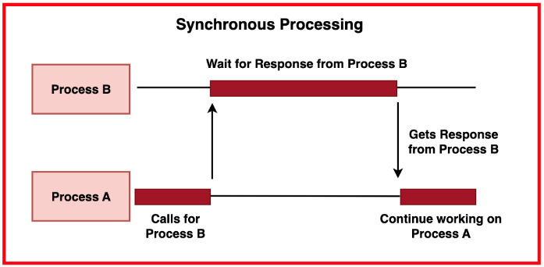



1. **Synchronous Non-Blocking**

Synchronous non-blocking operations return control to the caller immediately if the operation would block, allowing the caller to perform other tasks or check back later.

**Example:** Attempting to read from a non-blocking socket, which returns immediately if no data is available, letting the program continue other operations.

**Use Cases:** Applications that need to maintain responsiveness, like GUI applications or network servers handling multiple connections.

1. **Asynchronous Blocking**

Asynchronous blocking operations initiate a task and allow the caller to proceed with other operations. However, the caller is eventually blocked when it needs the result of the initiated task.

**Example:** Initiating a file read operation and continuing with other tasks, but blocking later when the data is needed and the read operation is not yet complete.

**Use Cases:** Scenarios where tasks can be initiated and performed concurrently, but the final results are needed for further processing, like in some multi-threaded applications.

1. **Asynchronous Non-Blocking**

Asynchronous non-blocking operations allow tasks to be initiated and completed without ever blocking the caller. Completion is usually handled via callbacks, events, or polling.

**Example:** Using an asynchronous API to read from a file or a network socket, where a callback function is invoked once the read operation completes.

**Use Cases:** High-performance servers, real-time systems, and applications where maintaining maximum responsiveness and concurrency is crucial, such as web servers or user interface applications.

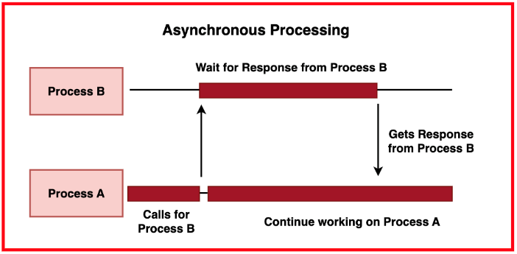



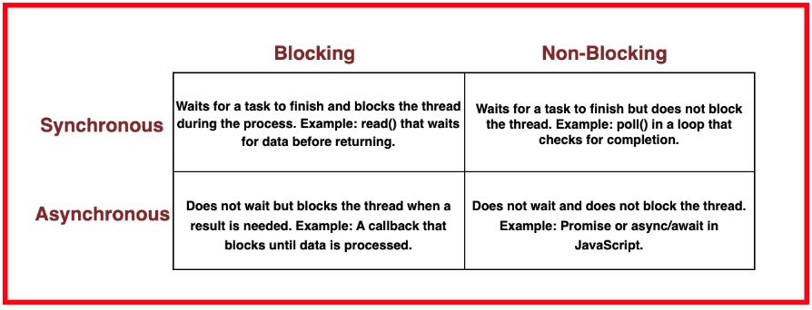

**Performance Comparison**

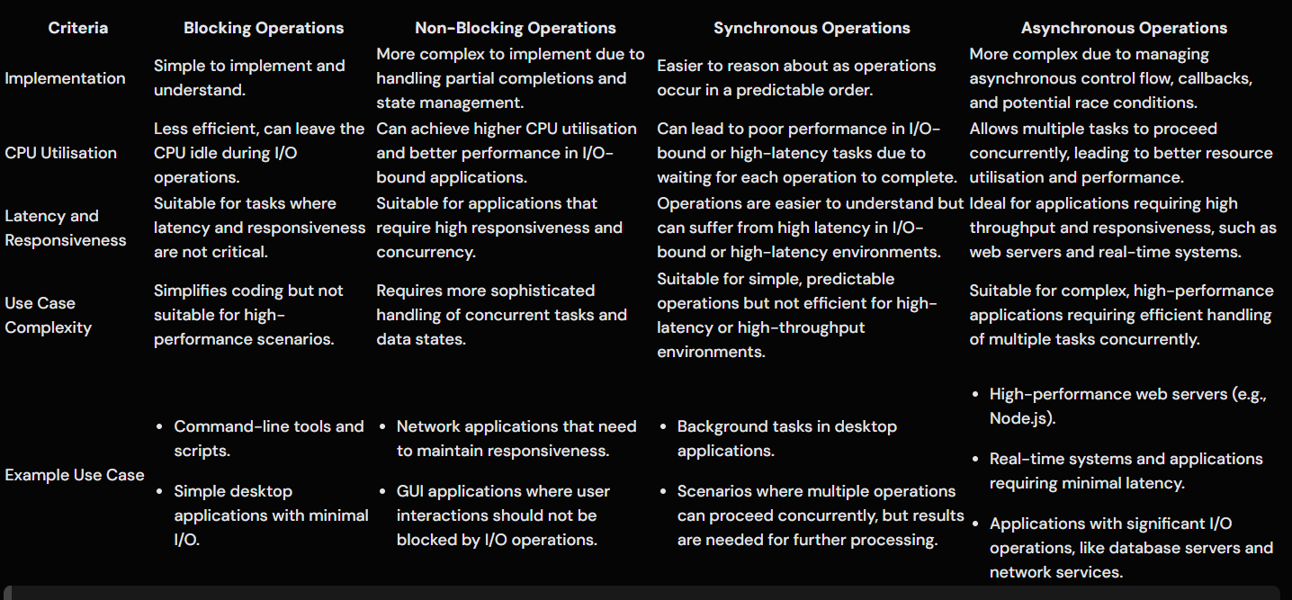

**synchronous vs. asynchronous**

**Synchronous communication** refers to a type of operation where tasks are performed sequentially, and each task must be completed before the next one starts. In this mode, the system waits for an operation to complete before moving on to the next operation. This approach ensures a predictable and orderly execution flow but can lead to inefficiencies, especially in I/O-bound tasks, where the CPU may be idle while waiting for operations to complete.

**Asynchronous communication** allows tasks to be performed concurrently. Operations can be initiated and then processed in the background while the system moves on to other tasks. This approach does not wait for each task to complete before starting the next one, leading to better resource utilization and responsiveness. Asynchronous communication is more complex to implement due to the need to handle tasks that can complete out of order and manage callbacks or events.

**Synchronous Communication**

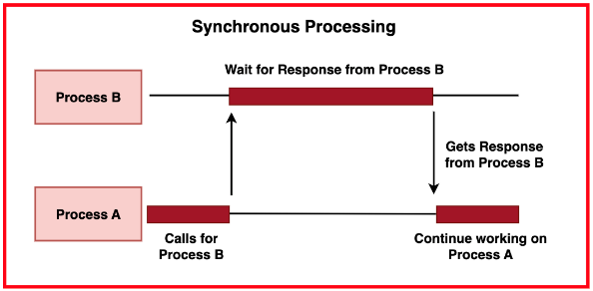

* **Sequential Execution:** Operations are executed one after another. Each task must be completed before the next one starts, making the execution flow predictable and easy to understand.
* **Resource Utilisation:** Can lead to inefficient use of system resources, as the CPU might be idle while waiting for I/O operations to complete.
* **Latency:** Higher latency in I/O-bound or high-latency tasks due to waiting for each operation to complete.
* **Simplicity:** Easier to implement and debug because of the straightforward execution flow.
* **Use Cases:** Suitable for simple applications, batch processing, and scenarios where the simplicity of the code is more critical than performance.

**Asynchronous Communication**

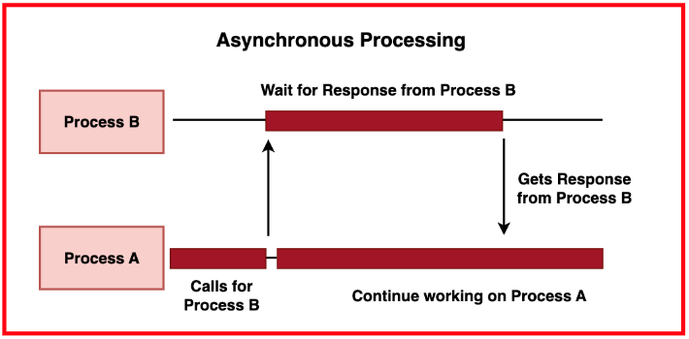

* **Concurrent Execution:** Tasks can be performed concurrently. Operations are initiated and then processed in the background, allowing the system to perform other tasks in parallel.
* **Resource Utilisation:** More efficient use of system resources, leading to better performance and responsiveness.
* **Latency:** Lower latency in I/O-bound or high-latency tasks due to the ability to initiate multiple operations simultaneously and continue processing other tasks.
* **Complexity:** More complex to implement and debug due to the need to manage asynchronous control flow, callbacks, and potential race conditions.
* **Use Cases:** Ideal for high-performance applications, real-time systems, web servers, and scenarios requiring high throughput and minimal latency.

**Blocking vs Non-Blocking in Synchronous Communication**

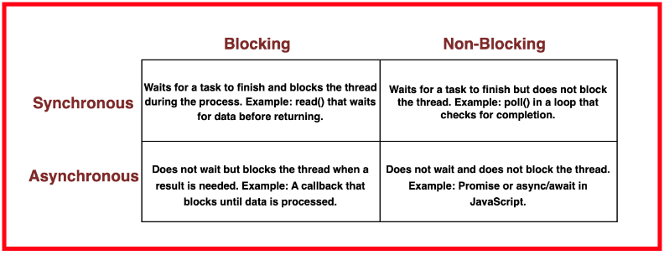

|  |  |  |
| --- | --- | --- |
| **Criteria** | **Blocking in Synchronous Communication** | **Non-Blocking in Synchronous Communication** |
| **Definition** | The process or thread waits (blocks) for an operation to complete before moving on to the next one. | The process or thread does not wait for an operation to complete. Instead, it checks periodically or uses other mechanisms to proceed with other tasks. |
| **Impact on Performance** | Can lead to idle waiting and underutilization of CPU resources, especially in I/O-bound tasks. | Better CPU utilisation but can be more complex to manage due to the need to handle partial completions and state management. |
| **Simplicity** | Easier to implement because of the straightforward sequential execution. | More complex than blocking operations but still follows a sequential execution flow. |
| **Latency** | Higher latency due to waiting for each operation to complete. | Lower latency compared to blocking operations, as the system can continue processing other tasks. |
| **Example** | Reading a file where the process waits until the entire file is read before continuing. | Attempting to read from a non-blocking socket, which returns immediately if no data is available, allowing the program to perform other operations. |

**Blocking vs Non-Blocking in Asynchronous Communication**

|  |  |  |
| --- | --- | --- |
| **Criteria** | **Blocking in Asynchronous Communication** | **Non-Blocking in Asynchronous Communication** |
| **Definition** | The operation is initiated asynchronously, but the process or thread eventually blocks when it needs the result of the initiated task. | Operations are initiated and processed asynchronously, and the process or thread never blocks, instead using callbacks or events to handle completions. |
| **Impact on Performance** | Can improve overall performance by initiating tasks concurrently but may still suffer from some blocking delays. | Maximises performance and resource utilisation by handling multiple operations concurrently without blocking. |
| **Simplicity** | More complex than synchronous blocking but less efficient than fully asynchronous non-blocking operations. | Most complex to implement and debug due to the need to manage asynchronous control flow, callbacks, and potential race conditions. |
| **Latency** | Improved compared to synchronous blocking but not as efficient as non-blocking asynchronous operations. | Lowest latency and highest efficiency due to continuous processing without waiting for individual tasks to complete. |
| **Example** | Initiating a network request and continuing with other tasks, but blocking when the response is needed. | Using an asynchronous API to read from a network socket, where a callback function is invoked once the read operation completes. |

**Real-World Applications and Examples**

* **Synchronous Blocking:**
  + Command-Line Tools: Simple utilities like cp (copy) or ls (list) that perform a sequence of operations and wait for each to complete.
  + Batch Processing: Scripts or applications that process files one at a time, ensuring that each file is fully processed before moving on to the next.
* **Synchronous Non-Blocking:**
  + Network Servers: Servers that need to maintain responsiveness by checking the status of non-blocking socket operations periodically.
  + GUI Applications: Applications that need to perform background tasks without freezing the user interface, such as checking for updates while allowing user interactions.
* **Asynchronous Blocking:**
  + Background Tasks in Desktop Applications: Initiating tasks like file downloads or data processing in the background, but blocking when the results are needed.
  + Concurrent Processing: Applications that initiate multiple I/O operations concurrently but may need to block to wait for certain critical results.
* **Asynchronous Non-Blocking:**
  + High-Performance Web Servers: Servers like Node.js that handle thousands of concurrent connections by using non-blocking I/O and asynchronous operations.
  + Real-Time Systems: Systems that require minimal latency, such as trading platforms or real-time analytics, where operations are processed as they complete without blocking.
  + Large-Scale Data Processing: Applications that process large volumes of data concurrently, such as big data platforms and distributed databases, using asynchronous non-blocking operations for maximum throughput and efficiency

**Spooling**

**Spooling** (Simultaneous Peripheral Operations On-Line) is a method used in computing to manage data by placing it in a temporary storage area (usually a buffer or spool) to be processed at a later time. This technique helps in handling I/O operations efficiently, especially when dealing with slower peripheral devices like printers, disks, or network connections.

Spooling is designed to manage the execution of jobs in a queued manner, allowing for efficient scheduling and processing. It enables a system to continue performing other tasks while waiting for I/O operations to complete.

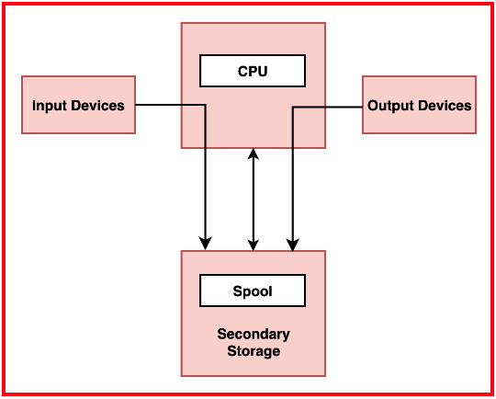

Data is temporarily stored in a buffer or a dedicated spool file. This data is then retrieved and processed sequentially by the appropriate device or application. Originally developed to handle batch processing in mainframe computers, spooling has evolved to become a critical component in modern operating systems. It typically involves a spooler, which manages the queue, and spooled devices, which process the queued data. Common examples include:

**Print Spooling:**

Refers to the process of queuing print jobs to be processed by a printer. This allows users to submit multiple print jobs without waiting for each one to complete before starting the next.

A print spooler accepts print jobs from applications and stores them in a buffer. The printer then processes these jobs in the order they were received, enhancing user productivity by allowing them to continue working while print jobs are being processed in the background.

**Disk Spooling:**

Involves temporarily storing data on a disk before it is transferred to its final destination, often used in data-intensive applications.

Disk spooling improves system performance by smoothing out the demand on disk resources, reducing bottlenecks, and enhancing overall throughput. It is common in environments with large volumes of data transfer, such as: Database management systems, Video rendering, Large-scale data processing

Video editing software often uses disk spooling to manage temporary files during rendering or transcoding processes.

**Spooling Advantages and Disadvantages**

**Advantages:**

* Increases system efficiency by allowing other processes to continue while waiting for I/O operations to complete.
* Optimises the use of peripheral devices by managing queues and scheduling jobs effectively.
* Provides robust error handling mechanisms, retrying jobs or notifying users in case of issues.
* Enhances user productivity by allowing them to perform other tasks while waiting for jobs to complete.
* Facilitates the handling of multiple tasks concurrently, making it suitable for environments with high I/O demands.

**Disadvantages:**

* Adds complexity to the system, requiring additional components like spoolers and buffers.
* Consumes additional resources, such as disk space and memory, to manage the spool.
* May introduce delays in processing if the spooler becomes a bottleneck.
* Requires careful management and configuration to ensure optimal performance and avoid issues like buffer overflows.
* System performance can be heavily dependent on the efficiency of the spooling mechanism